2017 Taipei Universiade CEO Li-Chiung SU Scrutinized Venues and Competitions
September 2, 2016

Taipei Universiade CEO Scrutinized Venues and Competitions

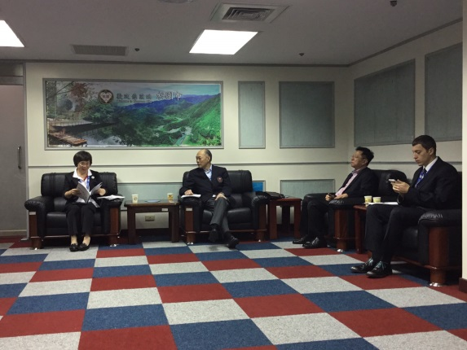

The 9th Asian Wushu Championships serve as a “test event” for the Taipei Summer Universiade to be held on August 19-30, 2017. Li-Chiung SU, Secretary-General of Taipei City Government, also CEO of the 29th Summer Taipei Universiade, led her executive team members to scrutinize the details of Taoyuan Arena and Competitions.

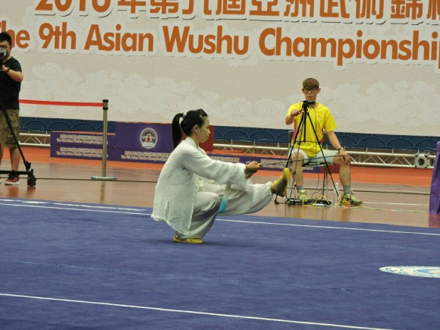

The second day continued with five Taolu competitions: Women's Changquan, Women's Taijijian, Women's Nangun, Men's Changquan, and Men's Nanquan. Vietnam snatched her first gold medal in Women's Taijijian, whereas China took home the remaining four golds. Chinese Taipei collected two silvers: Tse-Min TSAI (Men's Changquan) and Po-Wei LAI (Men's Nanquan).

Zhao-Hua WU (CHN) Celebrated His 18th Birthday with a Gold Medal

Zhao-Hua WU, an 18-year-old young athlete from China, ranked himself first places in several domestic competitions, including 2015 National Wushu Taolu Championships, 2015 Youth Sport Games (Changquan all-around), and 2016 Wushu Championships (Daoshu). This is his first debut in overseas’ competitions, he happily celebrated his birthday by taking home a gold medal in men's Changquan today.

"See Me Dazzling on Stages with 武Character" is his motto. Wu wishes to "Stand on Higher Awarding Podium.” As such, he hopes Wushu can be included in the Olympic Games.

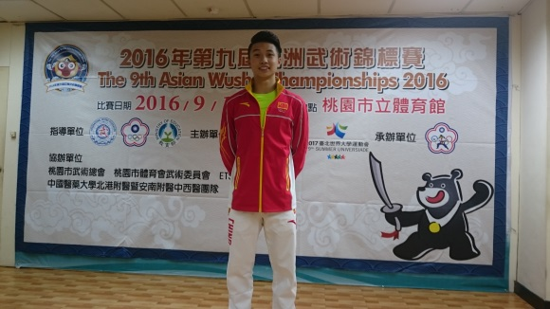

(Narrated by Allise HWANG and Lawrence LAN; photo’d by Zeng-Huei LIN)

2017台北世大運執行長蘇麗瓊視察場館及賽況
2016年9月2日

台北世大運執行長到訪視察

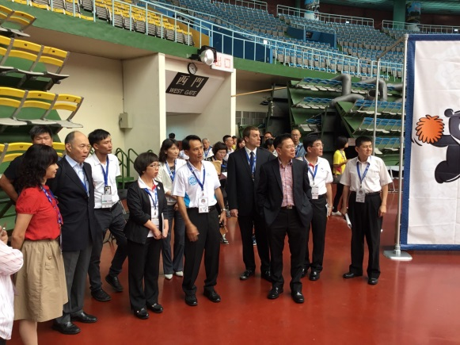

本屆錦標賽作為2017年8月19-30日在台北舉辦之夏季世界大學運動會武術比賽的「測試賽」。台北市政府秘書長蘇麗瓊，兼2017台北世大運執行長，今日率領世大運籌備人員蒞臨會場，視察各項場館設施、人員配當及比賽實況。

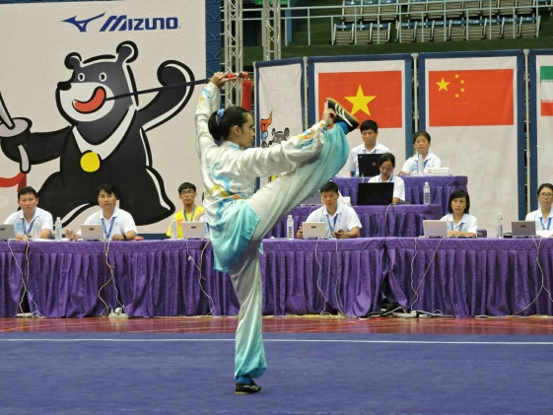

第二天繼續進行五場套路比賽，分別為女子長拳、女子太極劍、女子南棍、男子長拳、男子南拳。越南在女子太極劍首獲金牌，中國則囊括其餘四項金牌；中華台北由蔡澤民(男子長拳)和賴柏瑋(男子南拳)各摘一銀。

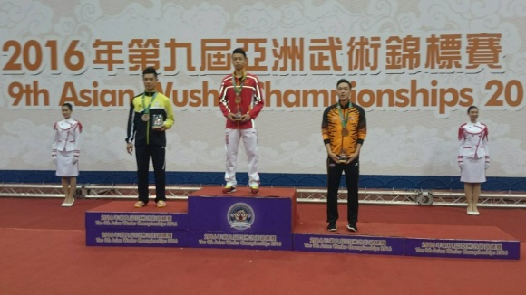

吳照華(中國)今天以金牌慶祝18歲生日

中國選手吳照華，曾獲2015年全國武術套路冠軍賽冠軍、2015年第一屆青運會長拳刀術全能冠軍、2016年武術套路錦標賽刀術冠軍。此次的亞錦賽是他第一次出國參賽，榮獲男子長拳金牌。

吳照華以「武字場上 看我輝煌」為座右銘，以「站在更高的領獎台上」自我期許，他希望「武術能進入奧運正式項目」。

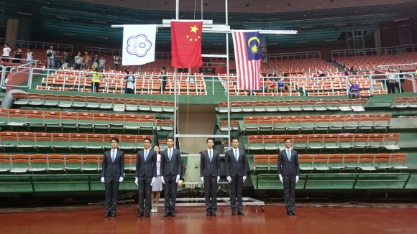
(撰文： 黃菊英、藍武王；相片：林增輝)

